LAB ACTION PLAN FOR WEEK 6

How to Run It
To run a multi-container setup like the one above:
- Save the file as docker-compose.yml.
Or
docker-compose.yaml
- To Start the compose
- 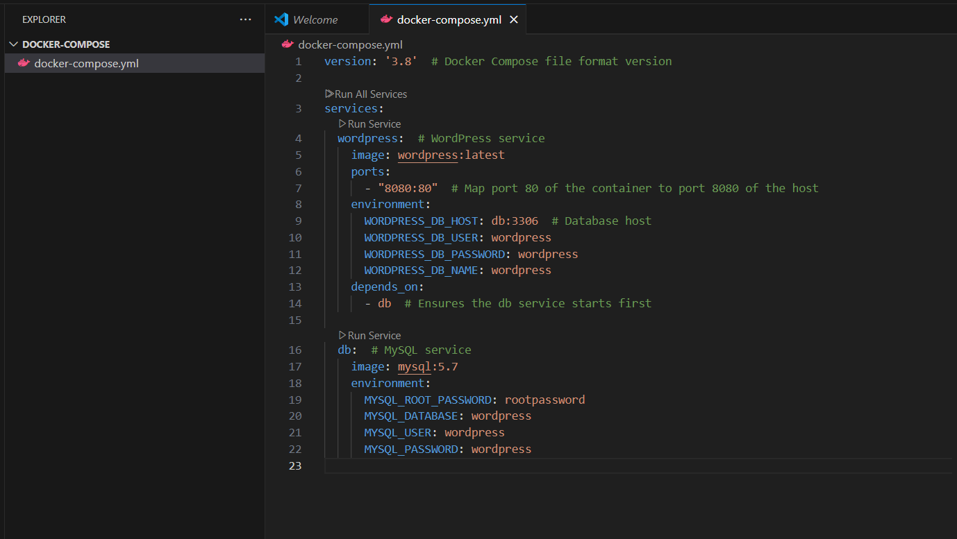

docker-compose up –d
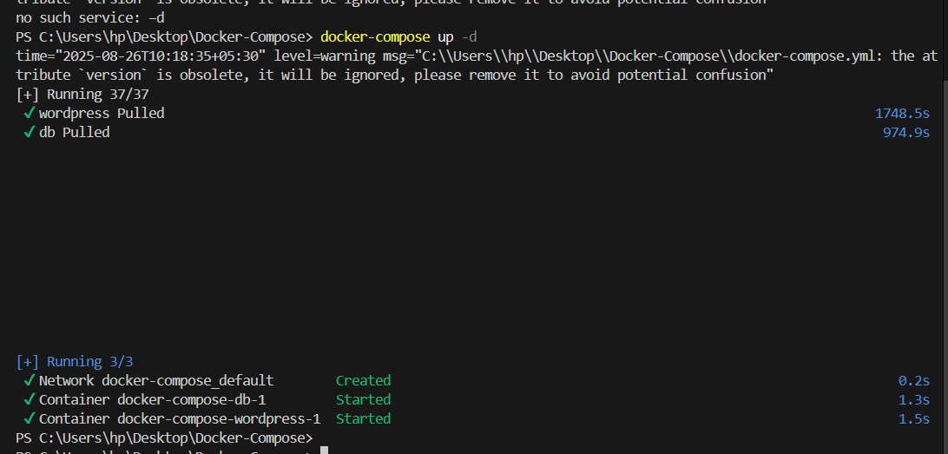
- To stop the containers
docker-compose down
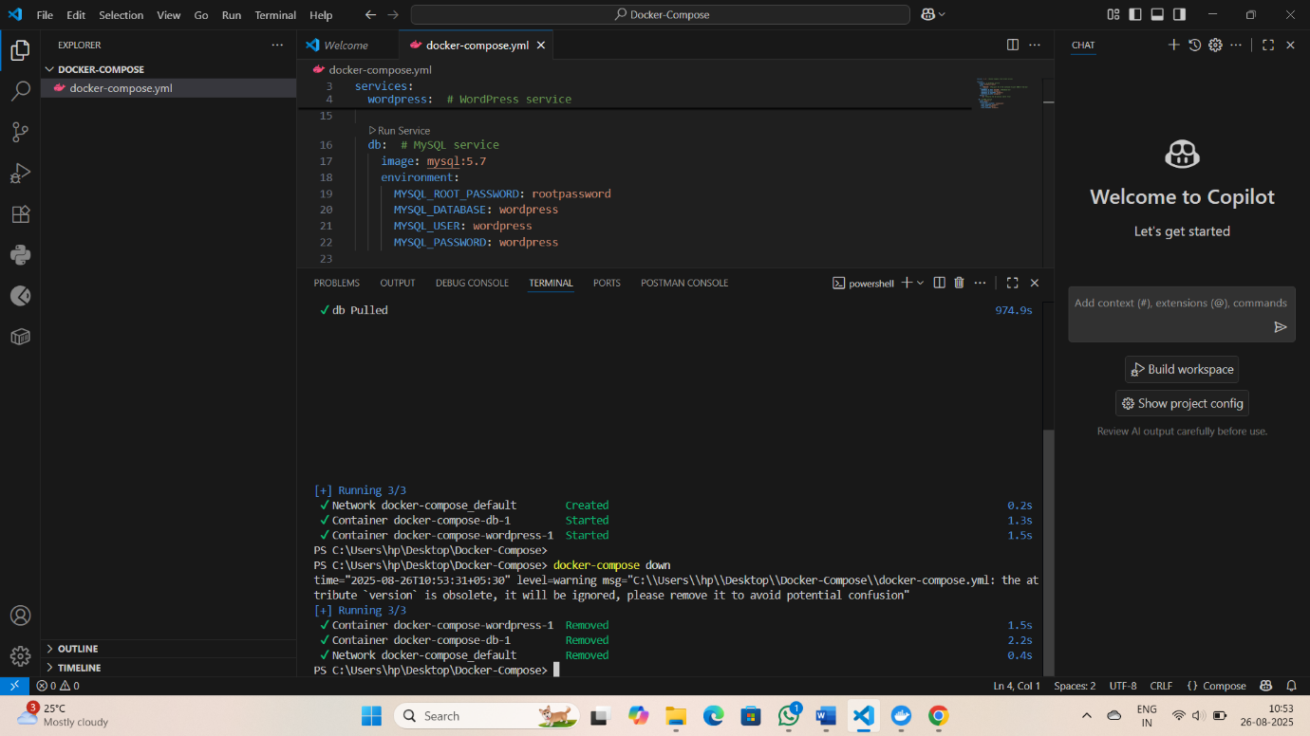

- To scale the container

docker-compose up --scale <service name>=2 -d
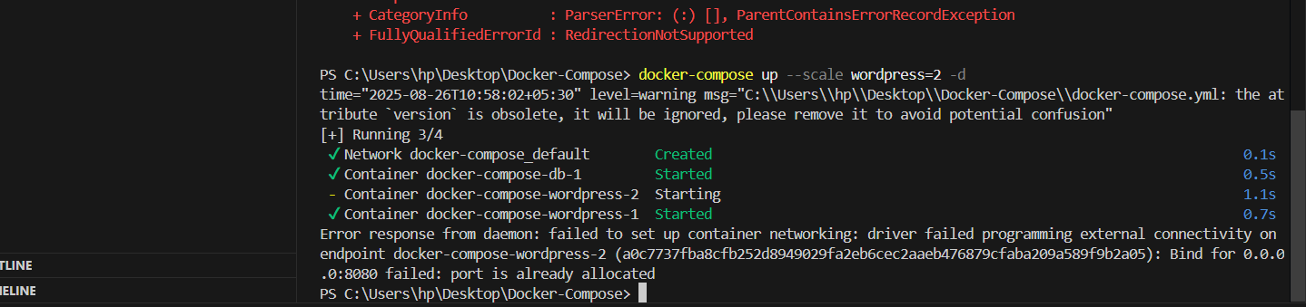

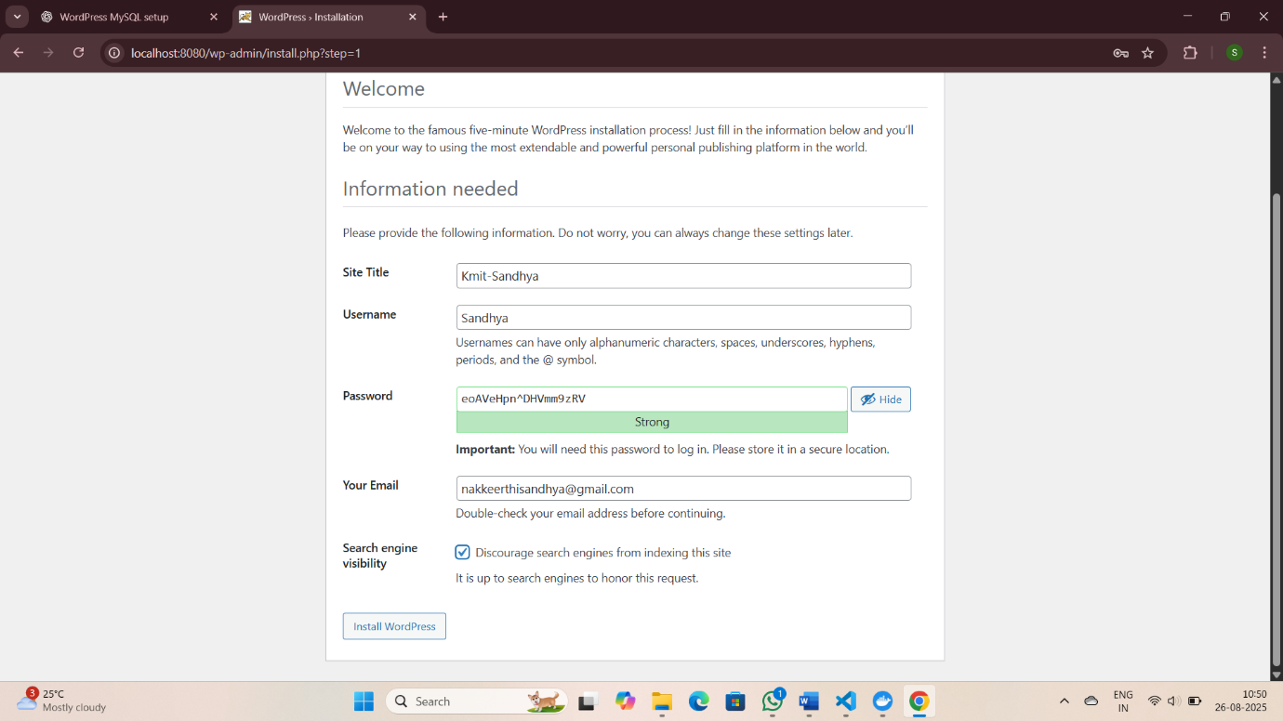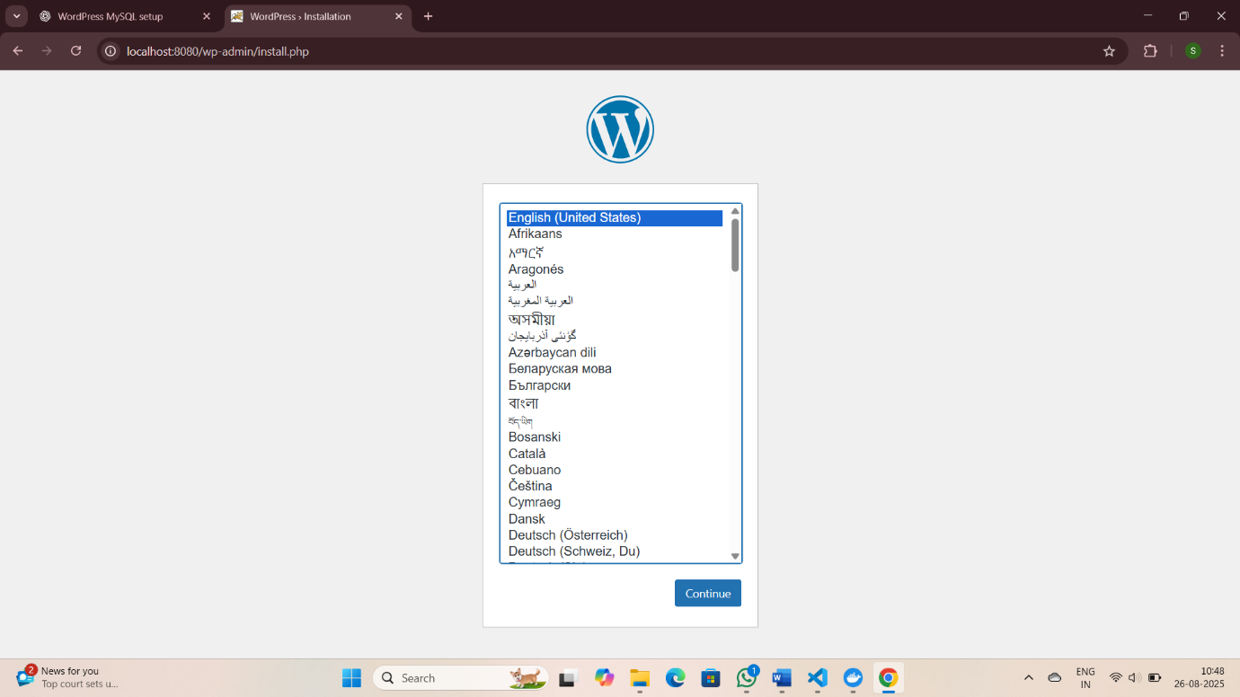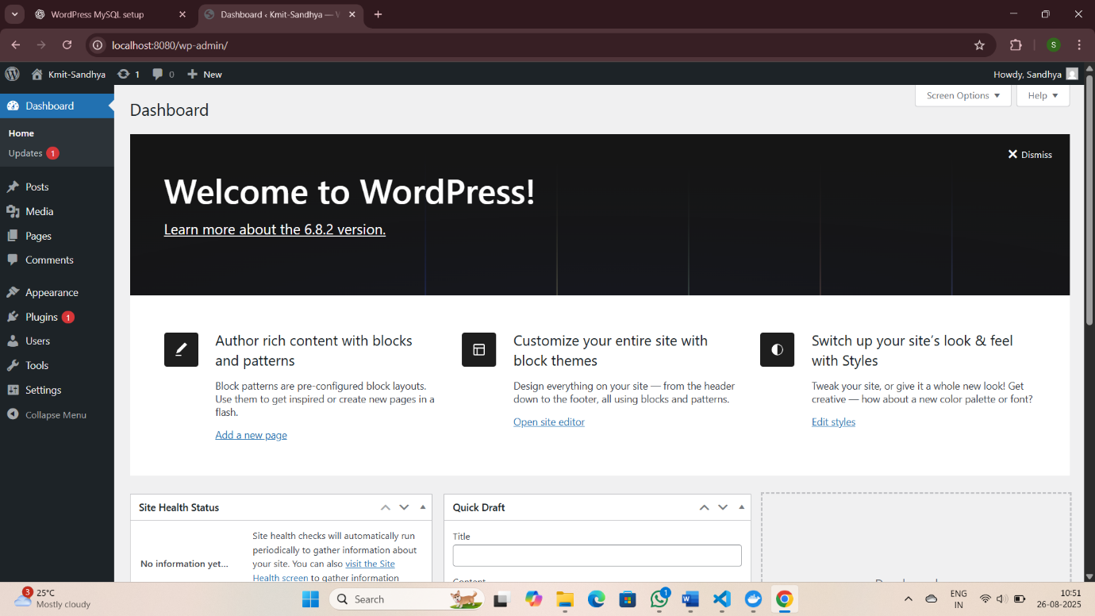
1.Define and run multiple interdependent services

Task:
- Create a new folder compose-lab
Inside it, create a file docker-compose.yml with the following content:

version: "3.9"
services:
web:
image: nginx:latest
ports:
- "8080:80"

db:
image: postgres:15
environment:
POSTGRES_USER: demo
POSTGRES_PASSWORD: demo
POSTGRES_DB: demo_db

II. Run the setup:

docker compose up -d
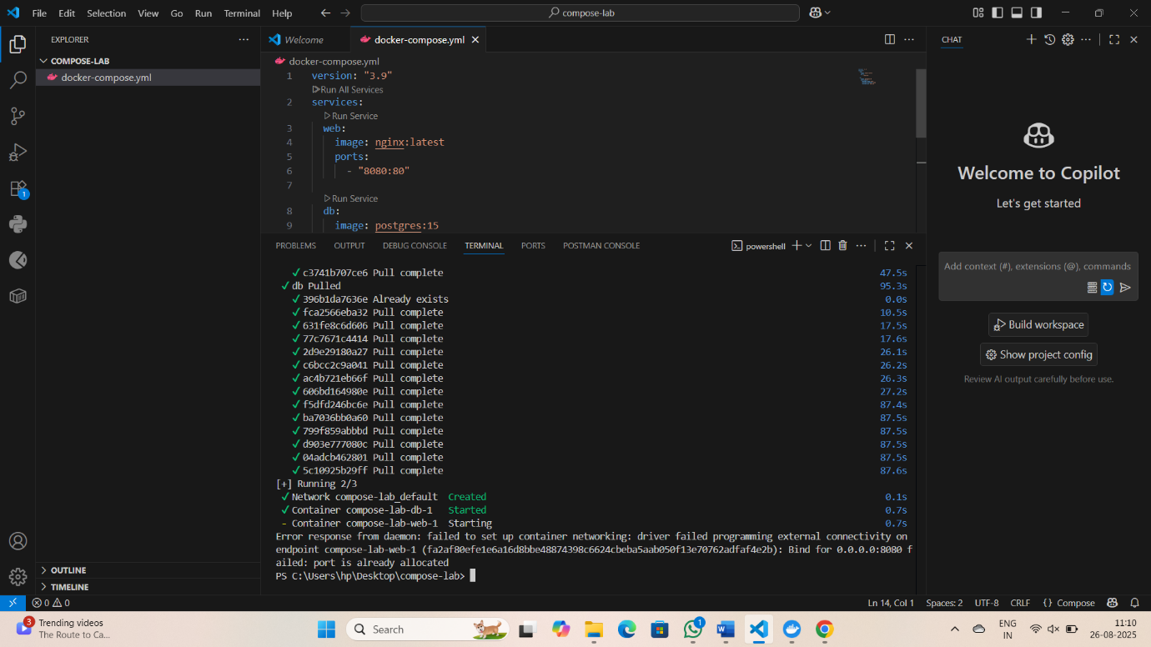
III. Open your browser and visit: http://localhost:8080.
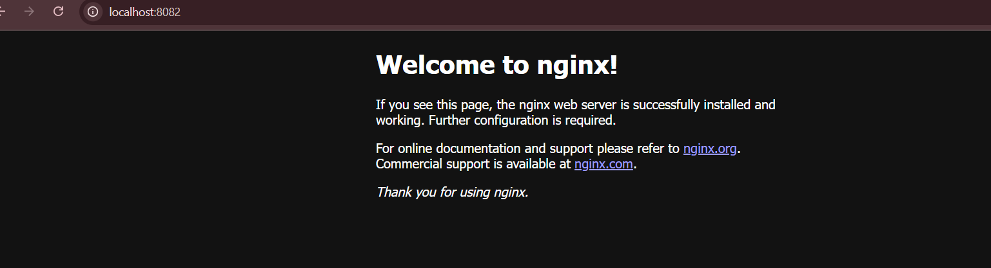
IV. Expected Output:

Nginx welcome page is displayed.
db container runs in the background.

2.Write and interpret docker-compose.yml files
Task:
- Modify docker-compose.yml to add a Redis cache:

redis:
image: redis:alpine

II. Add a depends_on so web waits for Redis:
web:
image: nginx:latest
ports:
- "8080:80"
depends_on:
- redis

III. Restart the setup:
docker compose up -d
docker compose ps

IV. Expected Output:

Three services (web, db, redis) are listed as running.

3.Deploy across different machines
Task:
- Zip your compose-lab folder.

Transfer it to another machine with Docker Compose installed.

II. Run:
docker compose up -d

Check that Nginx and Postgres work there as well.

III. Expected Output:
The same services run on the new machine without changes.

4.Networking and persistent storage
Task:
- Update your docker-compose.yml to add a custom network and volume:

networks:
app-net:

volumes:
db-data:

services:
web:
image: nginx:latest
ports:
- "8080:80"
networks:
- app-net
depends_on:
- db

db:
image: postgres:15
environment:
POSTGRES_USER: demo
POSTGRES_PASSWORD: demo
POSTGRES_DB: demo_db
volumes:
- db-data:/var/lib/postgresql/data
networks:
- app-net

II. Run:
docker compose up -d
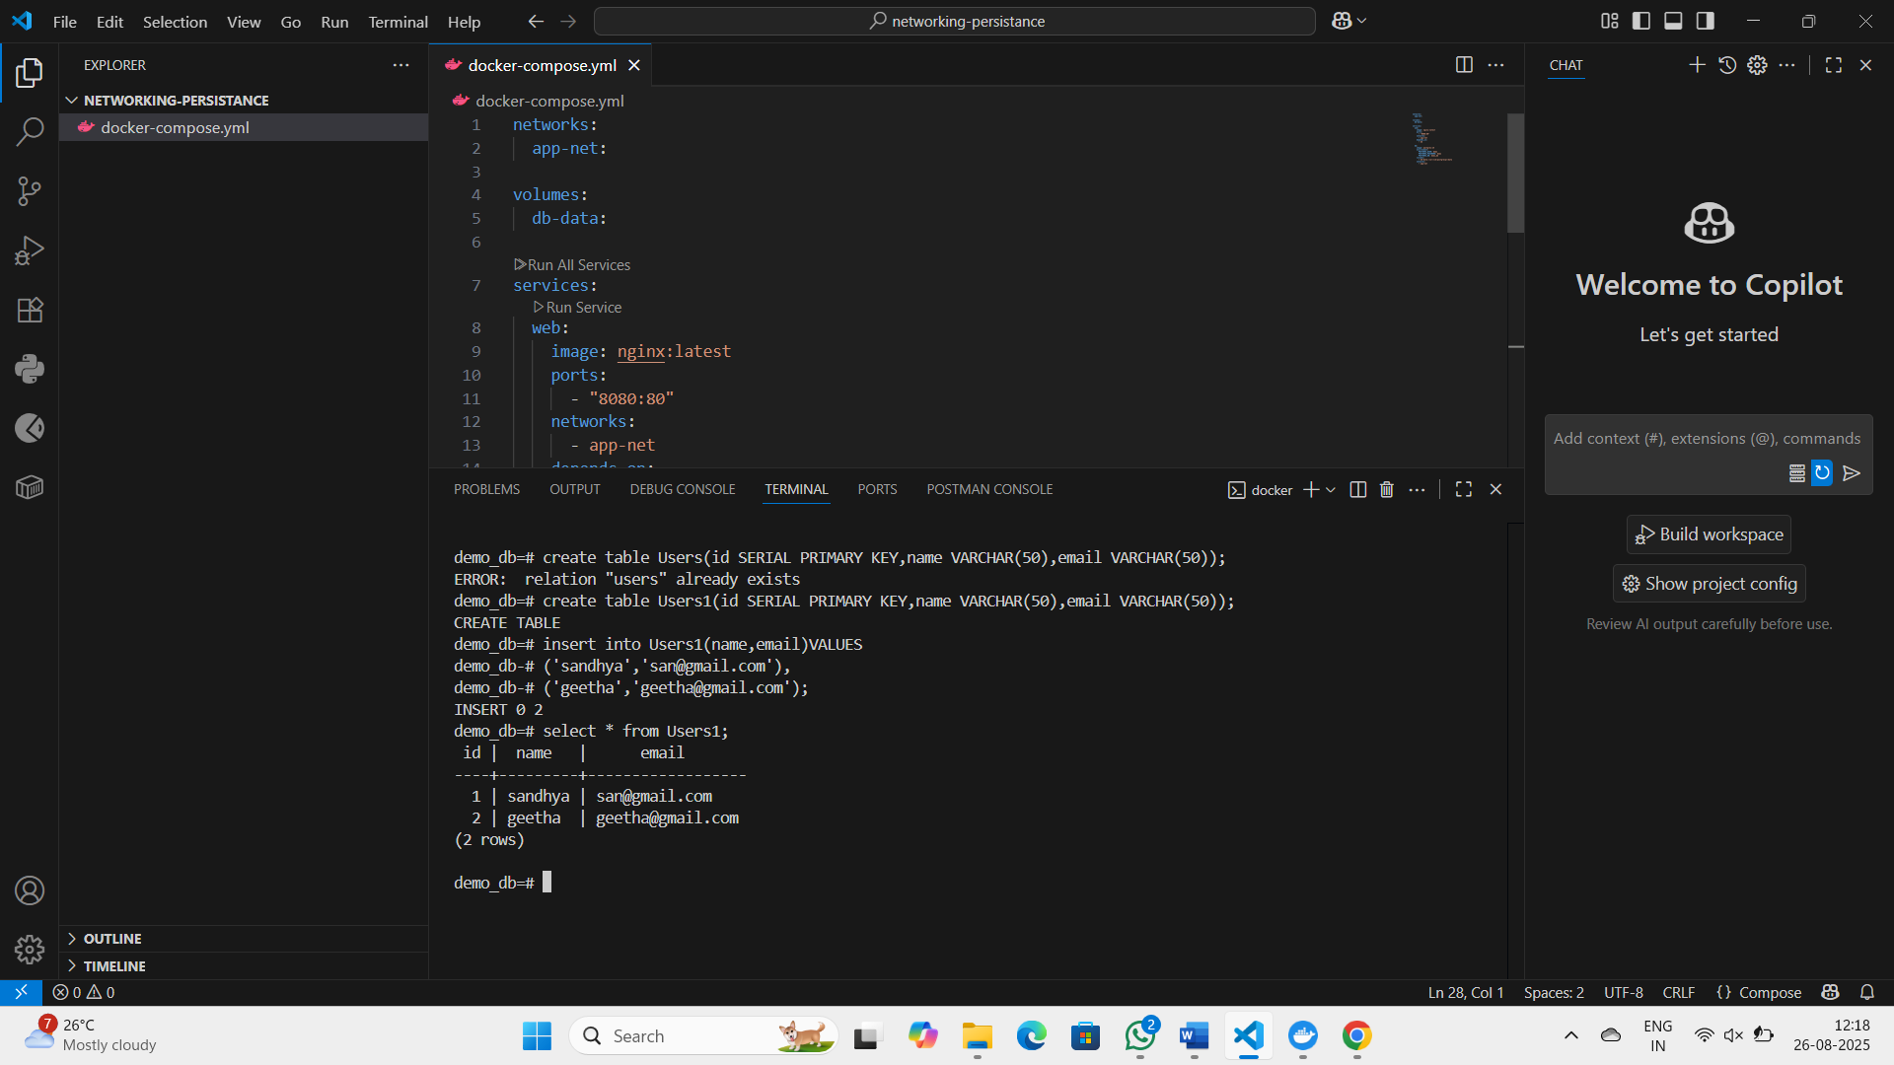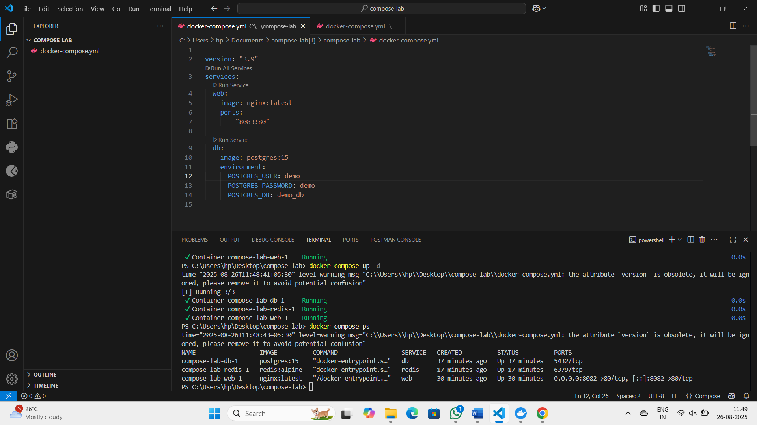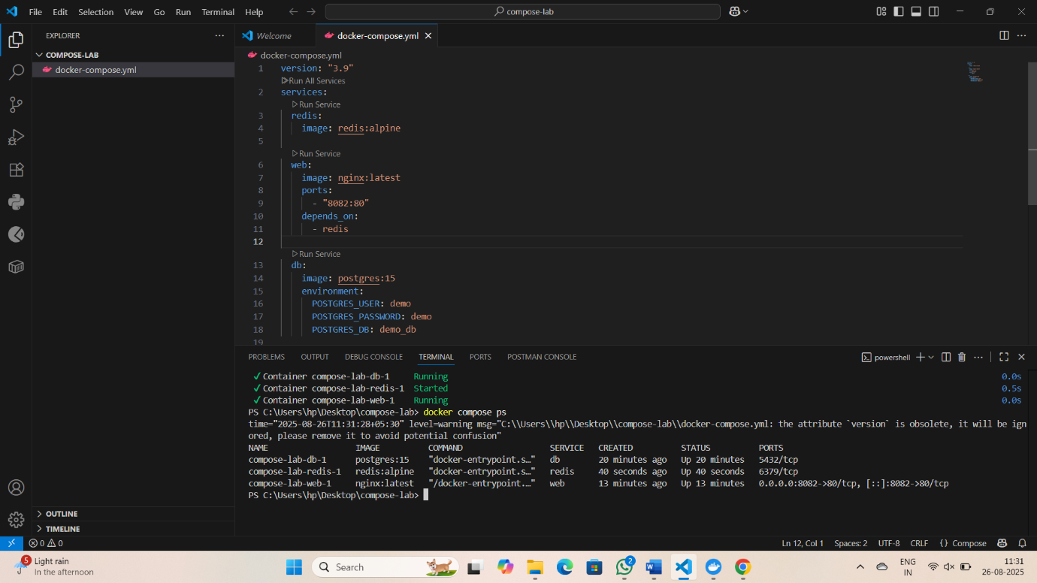
III. Insert some data into Postgres (optional with psql).
IV. Remove containers:
docker compose down
V. Start again:
docker compose up -d
VI. Expected Output:
Database data persists across restarts.
Services communicate via the app-net network using service names.

5.Faster iteration during development
Task:
- Create a simple Flask app in app.py:

from flask import Flask
app = Flask(__name__)
@app.route("/")
def home():
return "Hello from Flask + Docker!"
if __name__ == "__main__":
app.run(host="0.0.0.0", port=5000)

II. Add a Dockerfile in the same folder:

FROM python:3.10-slim
WORKDIR /app
COPY app.py /app/
RUN pip install flask
CMD ["python", "app.py"]

III. Update docker-compose.yml:
web:
build: .
ports:
- "5000:5000"
depends_on:
- db
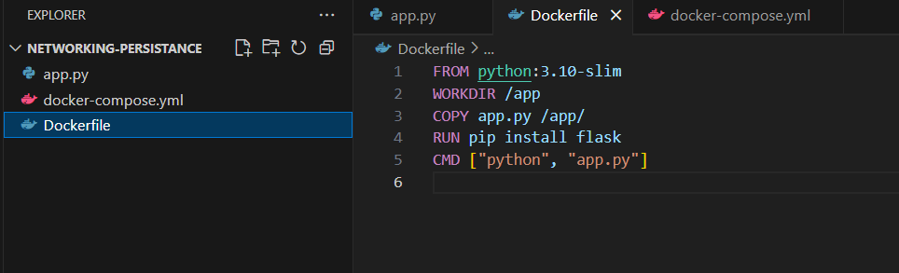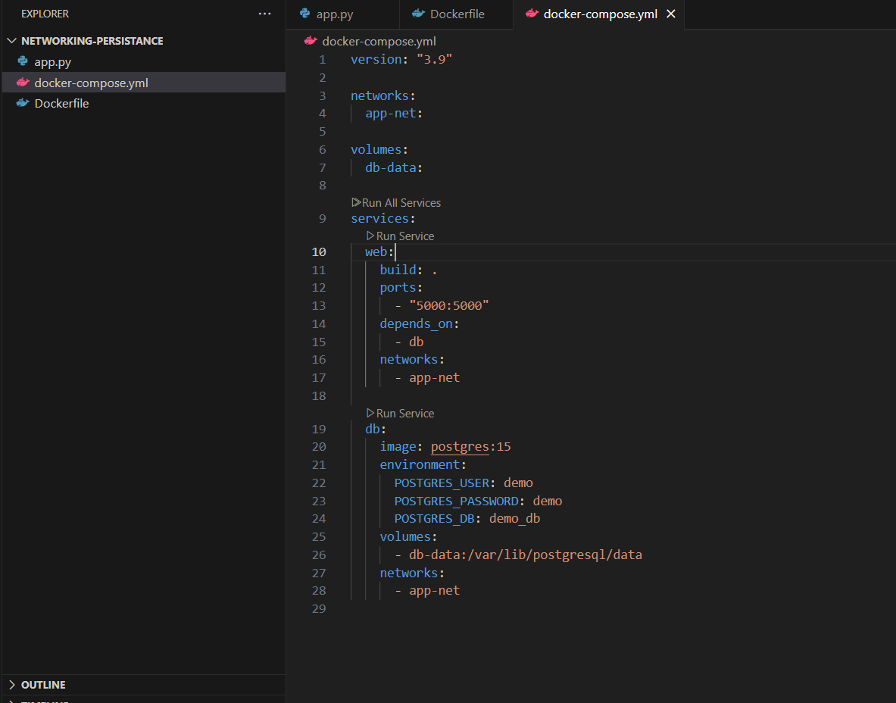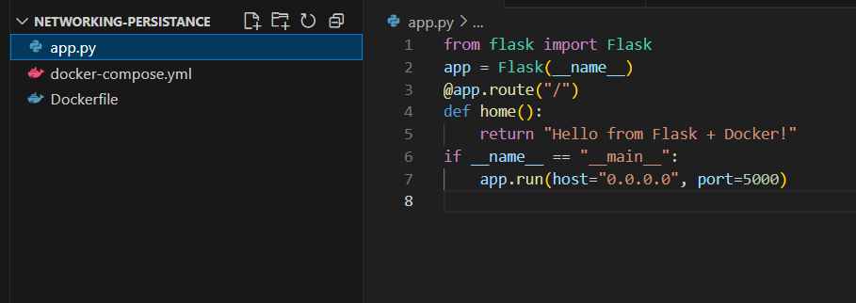
IV. Run:
docker compose up --build
Visit http://localhost:5000.
Change the return text in app.py (e.g., "Hello Docker Compose!").
V. Rebuild:
docker compose up –build
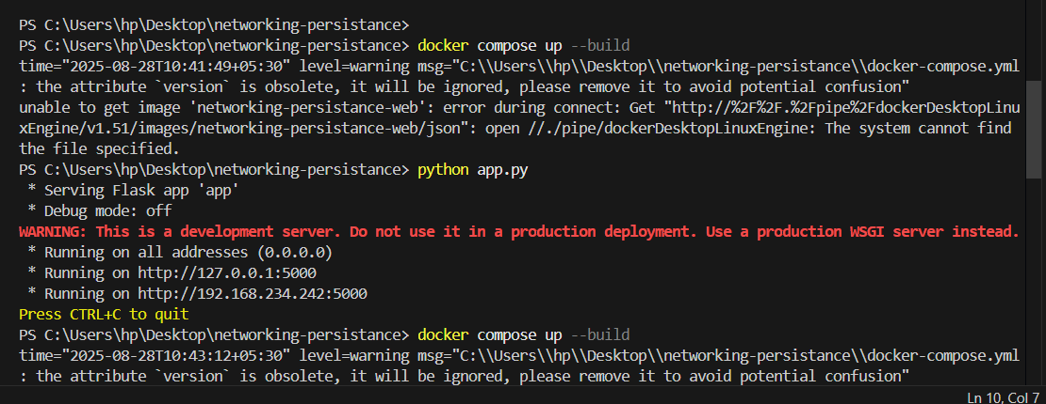
VI. Expected Output:
New message appears instantly after rebuild.
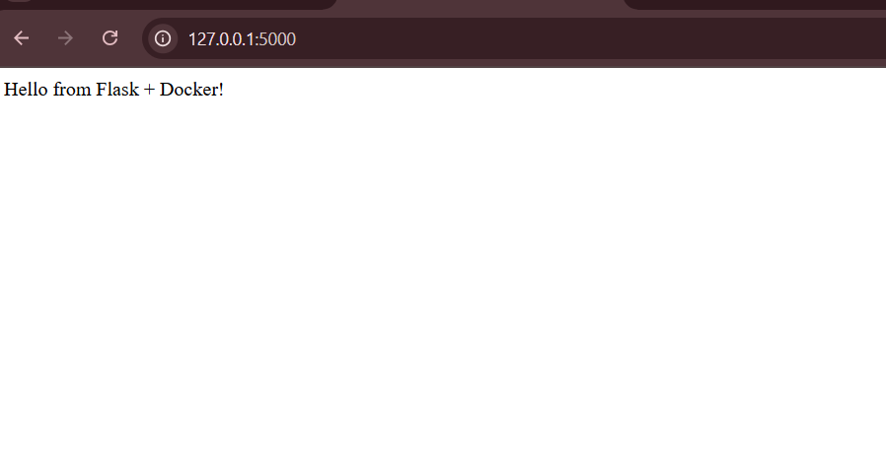
Scenario based Questions:
1. You have two applications — a Node.js backend and a Python script that handles scheduled jobs. You're considering running both inside the same container. Should you run multiple applications in the same Docker container?
2. You have a Flask API and an Nginx server. You want to run both containers on the same host and expose them on ports 5000 and 80 respectively. How can you expose both applications from different containers?
3. You want to run a React frontend, an Express.js backend and MongoDB – all together.
How do you run and manage all three together?
4. You try to run two containers that both expose port 8080 on the host.
What happens, and how can you run both apps?
5. You updated some code and want to restart your frontend, backend, and DB containers quickly. What is the easiest way to restart all services?
6. Your frontend has a new release, but you don’t want to restart the backend or DB.
How can you update and rebuild only the frontend container?
7. Tomcat is listening on port 8080, but you get a "Connection Refused" error in the browser. Why?
8. You're not sure which container is using port 3000. How do you check?
9. How do you stop and clean up your running Tomcat container and image?
10.You want to share your app with a teammate. What do you do with the Docker image?

Conclusion:
Docker Compose simplifies multi-container application management by allowing developers to define, configure, and run services in a single YAML file. It streamlines deployment, ensures consistent environments, and reduces manual setup, making it an essential tool for orchestrating complex, container-based applications efficiently.

